

**Joseph Banks  
Secondary College**

**Research Methods, Relational Influences and Cognition   
Worth 8% of the School Mark**

**Question/Answer Booklet**

**PSYCHOLOGY**

**Unit 3**

Student name : __________________________________________

# Time allowed for this paper

## Reading time before commencing work**: five minutes**

Working time for the paper: **fifty minutes**

# Materials required/recommended for this paper

***To be provided by the supervisor:***

This Question/Answer Booklet

Formulae and Data Booklet

***To be provided by the candidate:***

Standard items: pens (blue/black preferred), pencils (including coloured), sharpener,

correction tape/fluid, eraser, ruler, highlighters.

Special items: non-programmable calculators approved for use in the WACE examinations

# Important note to candidates

No other items may be taken into the examination room. It is **your** responsibility to ensure that you do not have any unauthorised notes or other items of a non-personal nature in the examination room. If you have any unauthorised material with you, hand it to the supervisor **before** reading any further.

**Structure of this paper**

|  |  |  |  |  |  |
| --- | --- | --- | --- | --- | --- |
| Section | Number of questions available | Suggested working time  (minutes) | Your Mark | Marks available | Percentage of test |
| Section One:  Research Methods | 3 | 20 |  | 17 | 50 |
| Section Two:  Short Answer | 2 | 27 |  | 28 | 50 |
|  |  | **Total** |  | 45 | 100 |

**Instructions to candidates**

1. The rules for the conduct of Western Australian external examinations are detailed in the *Year 12 Information Handbook 2016*. Sitting this examination implies that you agree to abide by these rules.
2. Write your answers in this Question/Answer Booklet.
3. When calculating numerical answers, show your working or reasoning clearly. Your working should be in sufficient detail to allow your answers to be checked readily and for marks to be awarded for reasoning.

In calculations, give final answers to one significant figures and include appropriate units where applicable.

1. You must be careful to confine your responses to the specific questions asked and to follow any instructions that are specific to a particular question.
2. Supplementary pages for the use of planning/continuing your answer to a question may have been provided at the end of this Question/Answer booklet. If you use these pages to continue an answer, indicate at the original answer where the answer is continued, i.e. give the page number.

**Section One – Research Methods (17 marks)**

**Question One (6 marks)**

Dr Chaz is planning an experiment to determine the effect of a study strategy called ‘mind mapping’ on student test scores at Marina Senior College. He used 100, 17-year-old Year 11 Psychology students, 50 of which he taught to use the mind mapping strategy and 50 which he did not.

1. Write an operational hypothesis for this experiment. (3 marks)

_______________________________________________________________________________________________________________________________________________________________________________________________________________________________________________________________________________________________________________________________________________

1. State the population from which the sample was drawn. (1 mark) ________________________________________________________________
2. State the independent variable: (1 mark)

________________________________________________________________

1. State the dependent variable: (1 mark)

________________________________________________________________

**Question Two (3 marks)**

Cognitive test scores for a group of students are listed below. (3 marks)

2, 1, 7, 9, 5, 5, 4, 11

Calculate the following:

Mean:

Median:

Range:

**Question Three (8 marks)**

A psychologist wanted to investigate the relationship between temperature and performance on a test of memory. The psychologist required a sample of 60 adults to participate, firstly in a room where the temperature was 16 °C; and secondly in a room where the temperature was 44 °C.

1. Outline **three** ethical considerations the psychologist must adhere to and **how** they can achieve this. (4 marks)

One: ____________________________________________________________________________________________________________________________________________________________________________________________________________________________________________________________________________

Two:

____________________________________________________________________________________________________________________________________________________________________________________________________________________________________________________________________________

1. Identify whether this is an experimental or non-experimental study and give a reason for your answer. (2 marks)

_______________________________________________________________________________________________________________________________________________________________________________________________________________________________________________________________________________________________________________________________________________

1. Identify whether the research above is scientific or non-scientific and give one reason for your answer. (2 marks)

_________________________________________________________________________________________________________________________________________________________________________________________________________

**Section Two- Short Answer Questions (15 marks)**

1. Define the term communication styles. Give two examples. (2 marks)

_________________________________________________________________________________________________________________________________________________________________________________________________________________________________

1. Describe the elaborative language code. (2 marks)

____________________________________________________________________________________________________________________________________________________________________________________________________________________________________________________________________________________________________________

1. Describe the restricted language code . (2 marks)

____________________________________________________________________________________________________________________________________________________________________________________________________________________________________________________________________________________________________________

1. Compare Labov and Bernstein’s theories of communication style (4 marks)

|  |  |
| --- | --- |
| **Similarities** | **Differences** |
|  |  |

1. *“Women create feelings of closeness by conversing with their friends and lovers. Men don’t use communication in this way, so they can’t figure out why their women are continually talk, talk, talking. Eventually, many men just tune their women out”*

- Laura Morrison commenting on Deborah Tannen’s book *You Just Don’t Understand*

Explain how men and women use communication for different purposes. Include in your answer how this can lead to misunderstanding and even conflict in a relationship. (*5 marks*)

______________________________________________________________________________________________________________________________________________________________________________________________________________________________________________________________________________________________________________________________________________________________________________________________________________________________________________________________________________________________________________________________________________________________________________________________________________________________________________________________________________________________________________________________________________________________________________

**Question 2 – Persuasive communication (13 marks)**

1. Compare the central and peripheral routes of persuasion. (4 marks)

|  |  |  |
| --- | --- | --- |
|  | **Role of the audience** | **Content of message** |
| **Central** |  |  |
| **Peripheral** |  |  |

1. Analysing the image below, identify and explain how one feature of persuasive communication has been used to make the advert persuasive. (3 marks)

________________________________________

________________________________________

________________________________________

________________________________________

________________________________________

________________________________________

________________________________________

________________________________________

________________________________________

________________________________________

________________________________________

________________________________________

c) Analysing the image below, identify and explain how one feature of persuasive communication has been used to make the advert persuasive. (3 marks)

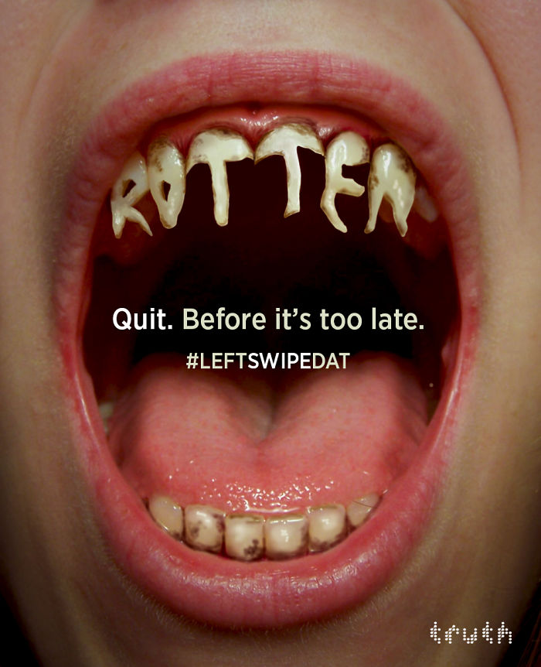

________________________________________

________________________________________

________________________________________

________________________________________

________________________________________

________________________________________

________________________________________

________________________________________

________________________________________

________________________________________

________________________________________

_______________________________________

1. Analysing the image below, identify and explain how one feature of persuasive communication has been used to make the advert persuasive. (3 marks)

______________________________________________________________________________________________________________________________________________________

______________________________________________________________________________________________________________________________________________________

